

**UNIVERSITI TUNKU ABDUL RAHMAN**

**Faculty of Engineering & Sciences**

**UECS3383 SOFTWARE QUALITY ASSURANCE**

**Assignment Part B1 & B2**

|  |  |  |
| --- | --- | --- |
| **Student ID** | **Student Name** | **Email** |
| **1500777** | **Heng Shu Ming** | **bookname1996@gmail.com** |
| **1800546** | **Lai Jia Yong** | **1800546@1utar.my** |
| **1800128** | **Leon Kang** | **Cataclysm123@1utar.my** |
| **1500982** | **Choo Jing Yuan** | **jingyuan0520@1utar.my** |

**Lecturer: Dr. Wong Whee Yen**

**TABLE OF CONTENTS**

**TABLE OF CONTENTS 1**

**Part B1**

|  |  |
| --- | --- |
| **ASSUMPTION** | **3** |
| **DEPLOYMENT POLICY** | **3** |
| **DEPLOYMENT GUIDELINES** | **3** |
| **DEPLOYMENT PROCESS FLOW** | **7** |
| **DEPLOYMENT WORKFLOW** | **8** |
| **DEPLOYMENT WORK INSTRUCTIONS** | **9** |
| **FORM TEMPLATE (I) - DEPLOYMENT CHECKLIST** | **11** |
| **FORM TEMPLATE (II) - DEPLOYMENT TEST CASE** | **13** |
| **FORM TEMPLATE (III) - DEPLOYMENT SIGN OFF FORM** | **14** |

**Part B2**

|  |  |
| --- | --- |
| **MAINTENANCE POLICY** | **15** |
| **MAINTENANCE GUIDELINES** | **15** |
| **MAINTENANCE PROCESS FLOW** | **17** |
| **MAINTENANCE WORKFLOW** | **18** |
| **MAINTENANCE WORK INSTRUCTIONS** | **19** |
| **FORM TEMPLATE (I) - MAINTENANCE CHANGE FORM** | **21** |
| **FORM TEMPLATE (II) - MAINTENANCE TEST FORM** | **22** |
| **FORM TEMPLATE (III) - SOFTWARE UPDATE LOG** | **23** |
| **FORM TEMPLATE (IV) - MAINTENANCE CHECKLIST** | **24** |
| **FORM TEMPLATE (V) - SOFTWARE RELEASE CHECKLIST** | **25** |

**REFERENCE DOCUMENT 26**

**Part B1**

**Implementation or Deployment Plan**

**a)**

**ASSUMPTION**

The clients from 15 different bank branches in the Klang Valley requested to have ATM machines deployment services that need to be completed within 1 month. The clients contact the company by sending emails or using the company’s client system to create the support tickets with details.

**b)**

**DEPLOYMENT POLICY**

The company will effectively deploy and test the ATM machines and ensure the ATM machines work without any major problems as well as within the satisfaction of the clients.

**DEPLOYMENT GUIDELINES**

Pre-Deployment Stage

1. Receive the support tickets and emails from the clients to request about the deployment of ATM machines.
2. Response to the tickets and emails within 3 working days to state the dates for the deployment to take place.
3. Form a group of 5 technical staff in a team as the ATM machines deployment team.
4. In overall, each member will be selected to handle 3 branches in an area within a month from the start till the end of every deployment process.
5. Each branch has at least 5 to 7 ATM machines to be installed or replaced and the total time for deployment process including documentation tasks per branch is 10 days.
   1. A minimum of 1 and a maximum of 2 ATM machines is needed to be installed per day by the programmer involved.
   2. A minimum of 4 and a maximum of 6 working hours is needed to complete the installation of one ATM machine.
6. Within a month or 30 days, all ATM machines in 3 branches should be deployed completely and successfully by a technical staff.
7. Double check the agreement letter and documents related to the deployment process.
8. Wear the proper technician uniform provided before going to the site.
9. Prepare and bring the ATM machine installation tools and materials before going to the site.
10. Refer to the standards below or prepare a contingency plan which consists of solutions or suggestions when something goes wrong.
    1. Assign at least 3 technical staff to handle all possible contingencies.
    2. When installation failure occurs, try to solve it by contacting technical staff in the company via WhatsApp.
    3. If the data migration failed or data lost, backup of the data should be recovered.
    4. If failures keep happening in the testing process, try to solve it by contacting technical staff in the company via WhatsApp.
    5. After contacting the technical staff and the problems still can’t be solved, delays will be implemented.
    6. When there are delays in the deployment process, send a formal email to explain the valid reasons to the clients and c.c. the email to the project members with higher positions.
    7. If the client accepted the reasons and the new dateline, the deployment processes will be continued.
    8. If the client rejected the reasons and the new dateline, further arrangement and discussion will be conducted.

Deployment Stage

1. Technical staff should be on site at 9am every working day.
2. Set a minimum of 4 hours and a maximum of 6 hours ATM machine downtime of an ATM machine.
3. Remove the existing ATM machine.
4. Install the new ATM machine to the empty slot.
5. Start the ATM machine’s operating systems and check for the connection issues.
6. Fix the connection issue by networking and linking it to the internet line.
7. Determine the data needed to be migrated to the new ATM machine.
8. Backup the data to the bank’s repository is suggested as some data are confidential or to the company’s repository after getting approval from the client.
9. Migrate the data to the new ATM machine.
10. Perform synchronization of the migrated data with the bank’s server.
11. Diagnose recovery of data and perform data checking that should be done in an hour.
12. Test the ATM machine main functionalities including cash withdrawals, deposits, funds transfers or account information inquiries.
13. Fix the functionality issues once the functionality problems have been found.
14. Retest the ATM machine until the working machine works well.
15. Fill in the Test Cases and Test Form.
16. Apply the solutions or suggestions from the contingency plan once technical staff has no choice but to do so.
17. End ATM machine downtime for initiation of the new ATM machine.
18. Repeat the process 1 to 17 until all of the ATM machines on the branch have been deployed and tested successfully.

Post-Deployment Stage

1. Update software log with the new ATM system details.
2. Take some photos to show the progress of the ATM machine deployment and send them to the company Whatsapp group.
3. Update the support tickets or send emails to inform the client about the completion of deployment.
4. Perform ATM machine demonstration to the client along with the checklist.
5. Discuss about the payment with the client in the bank.
6. Check for the client’s warranty status.
7. Provide a listing of all the necessary fees included to the client.
8. Charge for the ATM machine and deployment service fees that is around RM8000 per ATM machine and RM2000 for the servicing if the warranty status has expired and free of charge if the warranty status is still active.
9. Complete the checklist as attached in the next section.
10. Client accepts and signs off the documents.
11. Give the payment receipt and copies of the documents to the client who finished the sign off and payment process.
12. Upload all the documents to the company’s server in a day after the sign off process has been completed.
13. Conduct a 1 to 2 hours meeting to identify the mistakes and discuss the future improvement with the deployment team.
14. Conduct a 2 to 3 hours training for the new staff who are involved in the ATM machine deployment process.

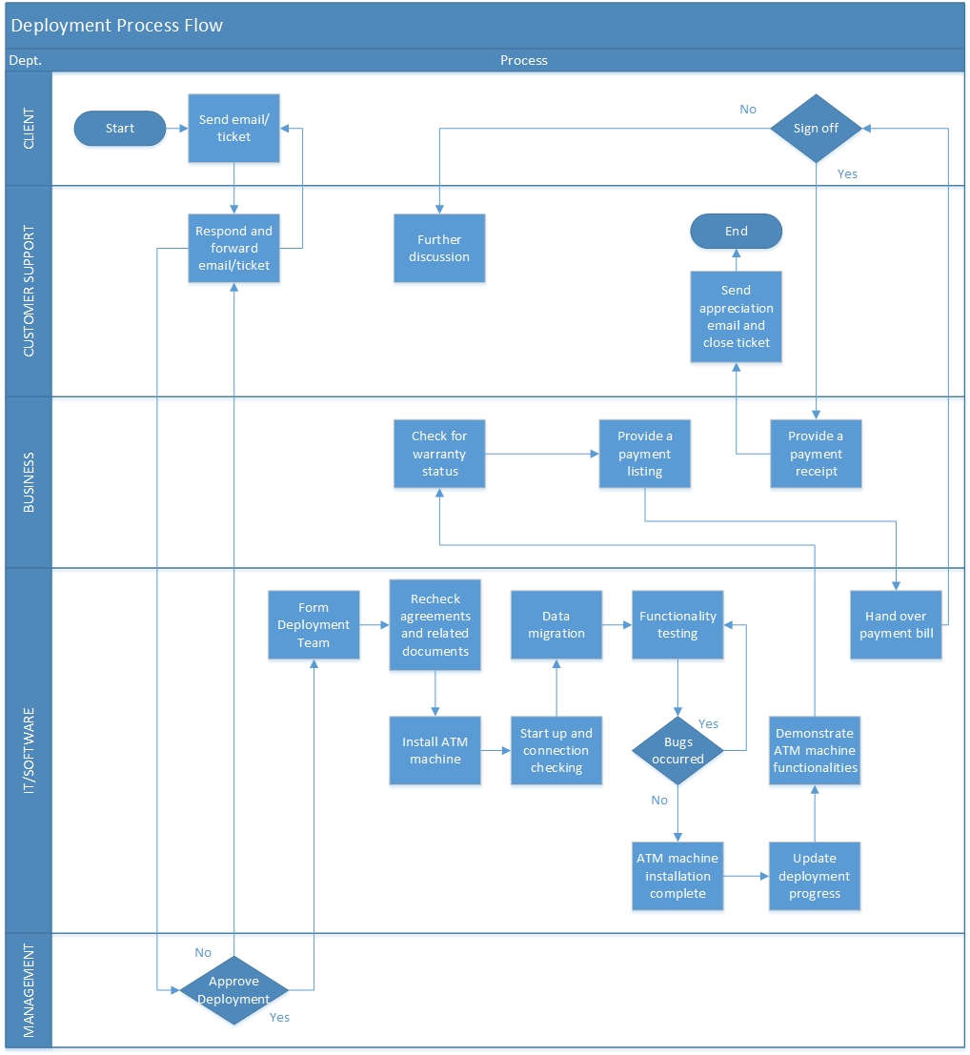**DEPLOYMENT PROCESS FLOW**

|  |  |
| --- | --- |
| Ref. No: DEPLOYMENT 01  Department: IT/Software  Process Title: **ATM Machine Deployment** | Date: 1-4-2020  Page: 1 of 1  Version: 1.0 |

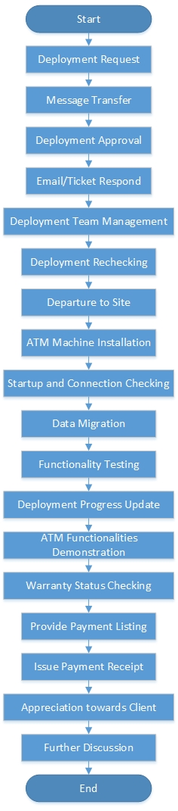**DEPLOYMENT WORKFLOW**

**DEPLOYMENT WORK INSTRUCTIONS**

1. Deployment Request - The client sends email and ticket highlighting their request on deployment.

2. Message Transfer - Customer support receives the request and forward the message to the software department.

3. Deployment Approval - The top management approves the deployment request. Top management hands in the request to the software department.

4. Email/Ticket Respond - Customer support responses to the client about the status of the deployment and deployment date if the process gets approved.

5. Deployment Team Management - Project manager in the software department assigns 5 technical staff. Project manager will then assign each member to handle 3 branches in an area within a month.

6. Documents Rechecking - Project Manager in the Software department recheck the agreement letter and documents.

7. Departure to Site - Assigned deployment team reached the site for installation at 9AM

8. ATM Machine Installation - Technician removes old ATM machine. Install new ATM machine into empty slot.

9. Startup and Connection Checking - Technician starts operating system of new ATM machine. Check and fix connection issue if available by networking and linking to internet line

10. Data Migration - Technician backups data to bank repository. Migrate data to the new ATM machine. Technician synchronizes data with the bank server.

11. Functionality Testing - Technician tests the ATM machine functionalities like cash withdrawals, deposits, funds transfers or account information inquiries until the ATM machine works well.

12. Deployment Progress Update - Technician update software log containing new ATM system details. Technician updates to the company about the deployment progress by taking several photos of ATM machines.

13. ATM Functionalities Demonstration - Technician demonstrates the functionalities of the new ATM machines to the client based on the checklist.

14. Warranty Status Checking - Business department administrator checks for the warranty status of the client.

15. Provide Payment Listing - Business department provides listing of fee payments to the client involved via the technician.

16. Issue Payment Receipt - Business department’s administrator issues receipt and copies of documents to the client.

17. Appreciation towards Client - Customer support department sends appreciation email to the client if the documents have been signed off.

18. Further Discussion - Customer support department discusses with the client about the reasons of unsatisfactory and take further actions like informing the software department so that the deployment team will conduct a meeting with the client.

**c)**

**i) Deployment Checklist Template**

**DEPLOYMENT CHECKLIST**

CHECKLIST FOR DEPLOYMENT STAGE

|  |  |  |  |
| --- | --- | --- | --- |
| **No** | **Item** | **Person Responsible** | **✔** |
| 1 | ATM Machine Downtime Initiation |  |  |
| 2 | Old ATM Machine Removal |  |  |
| 3 | New ATM Machine Installation |  |  |
| 4 | Operating Systems Startup |  |  |
| 5 | Connection Establishment |  |  |
| 6 | Data Backup |  |  |
| 7 | Data Migration |  |  |
| 8 | Data Synchronization |  |  |
| 9 | Data Recovery Diagnosis |  |  |
| 10 | ATM Machine Functionality Test |  |  |
| 11 | ATM Machine Regression Test |  |  |
| 12 | ATM Machine Technical Issues Fixed |  |  |
| 13 | ATM Machine Downtime Cancellation |  |  |

CHECKLIST FOR POST-DEPLOYMENT STAGE

|  |  |  |  |
| --- | --- | --- | --- |
| **No** | **Item** | **Person Responsible** | **✔** |
| 1 | Software log update |  |  |
| 2 | Progress update to company |  |  |
| 3 | Completion update to client |  |  |
| 4 | ATM machine demonstration |  |  |
| 5 | Payment discussion |  |  |
| 6 | Warranty status checking |  |  |
| 7 | Payment fees listing |  |  |
| 8 | Documents sign off |  |  |

*Please fill in the last checkbox before signing off.

**ii) Deployment Test Case Template**

**DEPLOYMENT TEST CASE**

|  |  |  |  |
| --- | --- | --- | --- |
| **Test Case ID** |  | **Test Priority** |  |
| **Test Case Description** |  | | |
| **Pre-requisite** |  | **Post-requisite** |  |
| **Test Execution Steps:** | | | |
|
|
|
|
|
|

|  |  |  |  |  |  |
| --- | --- | --- | --- | --- | --- |
| **No.** | **Actions** | **Expected Result** | **Actual Result** | **Status** | **Notes/Comments** |
| **1.** |  |  |  |  |  |
| **2.** |  |  |  |  |  |
| **3.** |  |  |  |  |  |

**iii) Deployment Sign-Off Form Template**

**DEPLOYMENT SIGN-OFF FORM**

|  |  |
| --- | --- |
| **Project Name:** | **Project Manager:** |
| **Start Date:** | **Completion Date:** |
| **Project Duration:** | **Sponsor:** |
| **Project Goal:** | |
| **Project Deliverables:** | |
| **Clients:** | |
| By signing the document, I acknowledge that I have delivered all the stated deliverables at the agreed to quality levels. | By signing this document, I acknowledge that I have received all the stated deliverables at the agreed to quality levels |
| **Project Manager Name and Signature:** | **Client Name and Signature:** |
| **Date:** | **Date:** |

|  |
| --- |
| **Remarks:** |

**Part B2**

**Software Change Control Quality Plan (Maintenance Part)**

**a)**

**MAINTENANCE POLICY**

The company will effectively monitor and control all changes to the ATM implementation and maintenance and make sure the clients are satisfied with our services provided

**MAINTENANCE GUIDELINES**

* 1. Technical staff should only handle a minimum of 2 ATM machines and maximum 4 ATM machines per day to ensure the quality produced.
  2. The maintenance period of each ATM machine should not be more than 3 hours, if a special emergency case happens, the technician must inform the technician leader for further arrangement and instructions.
  3. The maintenance period should be in between 10 am to 5 pm, otherwise specified request by the bank management.
  4. Each branch of the bank must be handled by 2 to 3 technicians.
  5. Get the signature approval for the change form from the technician leader.
  6. Inform and remind the bank admin and bank management 1 day before the maintenance period.
  7. The ATM data must be backed up to the company cloud database before the maintenance starts.
  8. Test the ATM machine main functionalities including cash withdrawals, deposits, funds transfers or account information inquiries.
  9. If there are new software features to be added to the ATM, the technician must ensure it is well integrated.
  10. After the maintenance, the technician must fill in the test form and get the approval from the technician leader.
  11. After the maintenance, the technician must fill in the test form and get the approval from the bank management and the technician leader and technician leader.
  12. Upload the soft-copy of the change form and test form to the company database within 1 hour after maintenance.
  13. The technician must submit both soft-copy of the signed change form and signed test form to the company database within 1 hour.
  14. The technician must submit both hard-copy of the signed change form and test form to the company administrator everyday before 5pm.

**MAINTENANCE PROCESS FLOW**

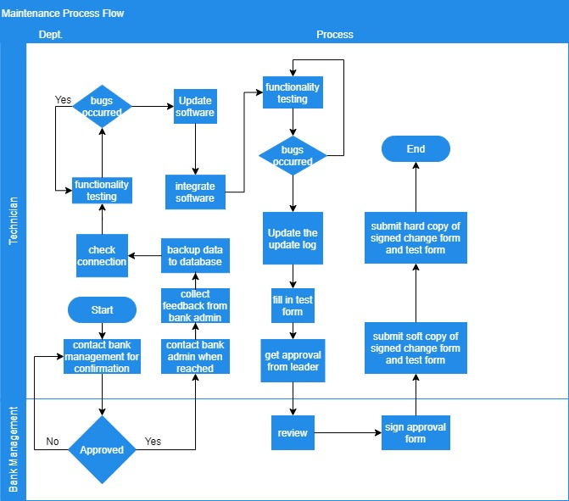

**MAINTENANCE WORKFLOW**

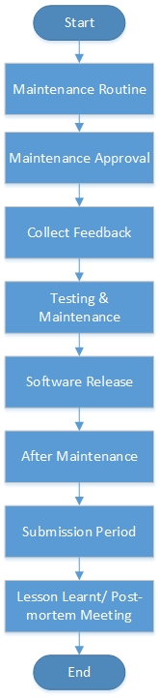

**MAINTENANCE WORK INSTRUCTIONS**

1. Maintenance Routine
   1. Every 2 weeks, the company will assign 2 technicians to the bank to maintain the ATM.
2. Maintenance Approval
   1. Get the signature approval from the leader technician for the change form.
   2. The technician will contact the bank management 1 day in advance before they depart to the bank to conduct the maintenance.
   3. After the management has approved, then the technician will reach the bank with the appointment time and date.
   4. The technician will contact the bank admin and management when they have reached the bank.
3. Collect Feedback
   1. The technician will collect the feedback from the bank admin and bank management.
4. Testing & Maintenance
   1. Backup the ATM data to the company cloud database.
   2. Start the ATM machine’s operating systems and check for the connection issues.
   3. Test the ATM machine main functionalities including cash withdrawals, deposits, funds transfers or account information inquiries.
   4. Fix the functionality issues once the functionality problems have been found.
   5. Retest the ATM machine until the working machine works well.
5. Software Release
   1. Update the new softwares and Operating System patch (to prevent security issues) for the ATM.
   2. Integrate the software updates with the existing ATM.
   3. Test the ATM machine main functionalities including cash withdrawals, deposits, funds transfers or account information inquiries.
   4. Retest the ATM machine until the working machine works well.
6. After Maintenance
   1. Update the ATM software update log and state the version and functionalities that recently added (if any).
   2. Fill in the test form.
   3. Get the signature approval from the leader technician for the test form.
   4. Update the bank admin and bank management about what has been fixed and which features are newly added.
   5. Let bank admin and bank management try out the ATM.
   6. Get the signature approval from the bank management.
7. Submission period
   1. The technician must submit both soft-copy of the signed change form and signed test form to the company database within 1 hour.
   2. The technician must submit both hard-copy of the signed change form and test form to the company administrator everyday before 5pm.
8. Lesson Learnt / Post-mortem meeting
   1. Every 2 weeks, the technician leader will host this meeting and all the team members must attend.
   2. Every team member will update the special case that they have faced and what they have learnt.
   3. A lesson learnt report is generated after the meeting and uploaded to the company database for future reference.

**b)**

**i) Change Request Form Template**

**CHANGE REQUEST FORM**

|  |  |
| --- | --- |
| **Project Name :** | |
| **Date :** | **Time :** |
| **Request by :** | **Request Number :** |
| **Change Description :** | |
| **Change Reason :** | |
| **Impact of change :**   * **Scope** * **Budget** * **Resourcing** * **Communication** * **Other** | |
| **Proposed action :** | |
| **Associated cost :** | |
| **Approved by :** | **Date :** |

**ii) Test Form Template**

**TEST FORM**

|  |  |  |  |
| --- | --- | --- | --- |
| **Project Name :** | | **Project Version :** | |
| **Project Environment :** | | | |
| **Test by :** | | | |
| **Date :** | | **Time :** | |
| **Test module Name :** | | | |
| **Testing Purpose :** |  | | |
| **Actions :** | **Testing Steps :** | **Expected Results :** | **Actual Results :** |
|  |  |  |  |
|  |  |  |  |
|  |  |  |  |
| **Approved By :** | | **Date :** | |

**iii) Software Update Log Template**

**SOFTWARE UPDATE LOG**

|  |  |
| --- | --- |
| **Project Name :** | |
| **Software Version :** | |
| **New Features :** | |
|  | |
|  | |
|  | |
| **Filled by :** | **Date :** |

**iv) Maintenance Checklist Template**

**MAINTENANCE CHECKLIST**

|  |  |  |  |
| --- | --- | --- | --- |
| **No** | **Item** | **Person Responsible** | **✔** |
| 1 | Backup the ATM data to the company cloud database. |  |  |
| 2 | Check for the connection issues. |  |  |
| 3 | Main functionalities : cash withdrawals |  |  |
| 4 | Main functionalities : cash deposits |  |  |
| 5 | Main functionalities :funds transfers |  |  |
| 6 | Main functionalities : account information inquiries. |  |  |

**(v) Software Release Checklist Template**

**SOFTWARE RELEASE CHECKLIST**

|  |  |  |  |
| --- | --- | --- | --- |
| **No** | **Item** | **Person Responsible** | **✔** |
| 1 | Backup the ATM data to the company cloud database. |  |  |
| 2 | Update the new softwares and Operating System patch |  |  |
| 3 | Integrate the software updates |  |  |
| 4 | Main functionalities : cash withdrawals |  |  |
| 5 | Main functionalities : cash deposits |  |  |
| 6 | Main functionalities :funds transfers |  |  |
| 7 | Main functionalities : account information inquiries. |  |  |

**REFERENCE DOCUMENT**

Checklist Template. Retrieved From: <https://hookedoninnovation.com/2012/09/05/ipad-deployment-checklist-for-k-12/>

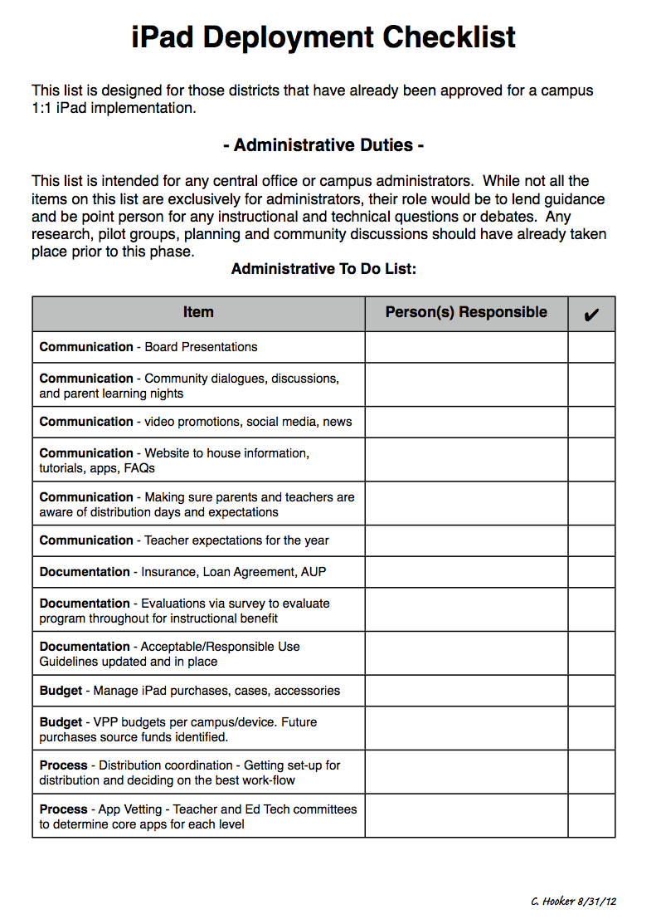

Test Case Template. Retrieved From: <https://www.softwaretestinghelp.com/test-case-template-examples/>

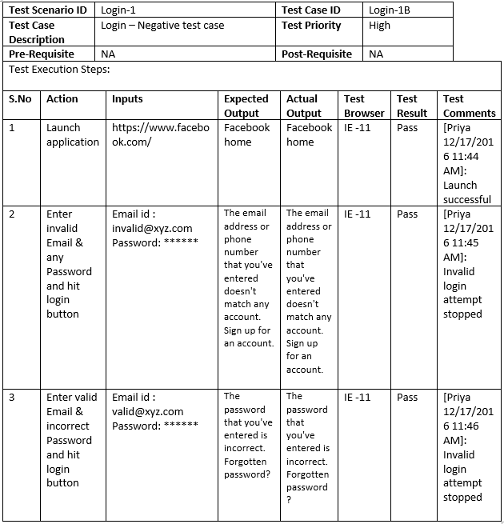

Sign-Off Form Template. Retrieved from: <https://filestage.io/blog/sign-off-sheet/>

